№ |  |  | Фото |  |  | Модель | Цена без кожаной вставки, руб. |  |  |  | Цена с кожаной вставкой, руб.
GALS
1 |  |  | 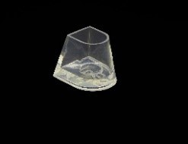 |  |  | Flare | 70 |  |  |  | 90
2 |  |  | 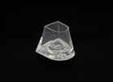 |  |  | Flare Cut | 70 |  |  |  | 90
3 |  |  | 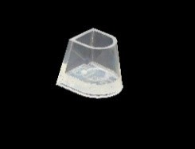 |  |  | Contour | 70 |  |  |  | 90
4 |  |  | 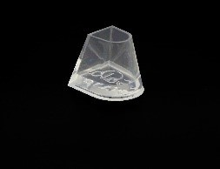 |  |  | Flare 2ʺ | 70 |  |  |  | 90
GALA
1 |  |  |  |  |  | Flare | 120 |  |  |  | 170
2 |  |  |  |  |  | Flare Cut | 120 |  |  |  | 170
3 |  |  |  |  |  | Flare Thick | 120 |  |  |  | 170
4 |  |  |  |  |  | Flare 2ʺ | 120 |  |  |  | 170
5 |  |  | 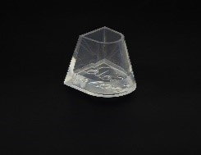 |  |  | Flare 2,5ʺ | 120 |  |  |  | 170
6 |  |  | 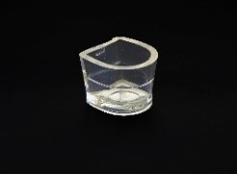 |  |  | Flare Inverted | 120 |  |  |  | 170
7 |  |  | 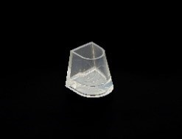 |  |  | Contour | 120 |  |  |  | 170
8 |  |  | 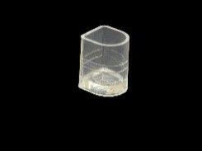 |  |  | Slim | 120 |  |  |  | 170
9 |  |  | 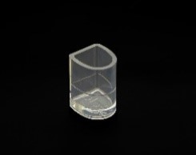 |  |  | Slim 2 | 120 |  |  |  | 170
10 |  |  | 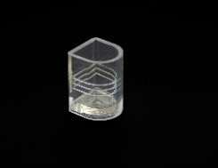 |  | Slim 3 |  |  |  | 120 |  | 170
11 |  |  | 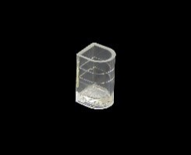 |  | Ultra Slim |  |  |  | 120 |  | 170
12 |  |  | 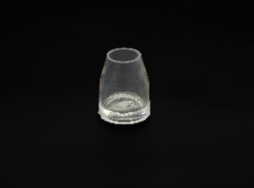 |  | Circle |  |  |  | 120 |  | 170
13 |  |  | 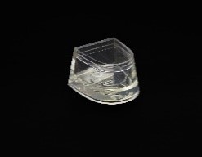 |  | Cuban |  |  |  | 120 |  | 170
14 |  |  | 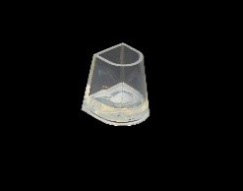 |  | Middle Flare |  |  |  | 120 |  | 170
15 |  |  | 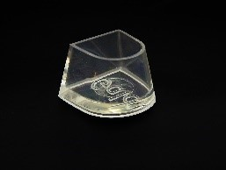 |  | PG 2,5ʺ |  |  |  | 170
16 |  |  | 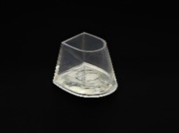 |  | Flare Rounded |  |  |  | 120 |  | 170
17 |  |  | 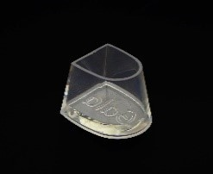 |  | German Style |  |  |  | 160
18 |  |  | 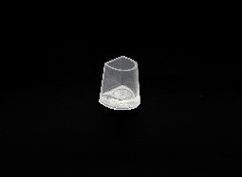 |  | Tango Argentino |  |  |  | 120 |  | 170
19 |  |  | 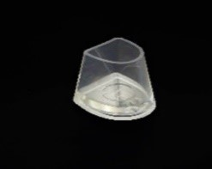 |  | Italian Style |  |  |  | 120 |  | 170
20 |  |  | 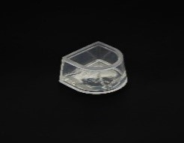 |  | Classic cuban |  |  |  | 120 |  | 170
21 |  |  | 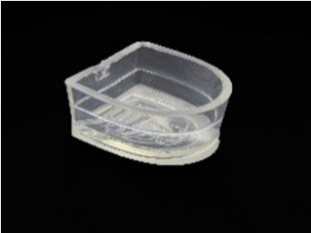 |  | HPR 21 |  |  |  | 200
22 |  | 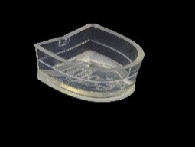 |  |  | HPR 22 |  |  | 220
23 |  | 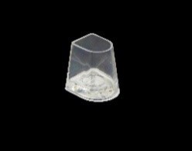 |  |  | HPR 23 |  |  | 120 |  |  | 170
24 |  | 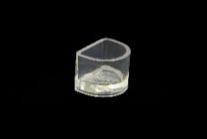 |  |  | HPR 24 |  |  | 120 |  |  | 170
25 |  | 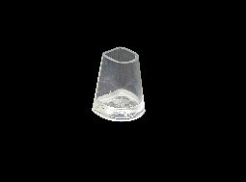 |  |  | HPR 25 |  |  | 120 |  |  | 170
26 |  | 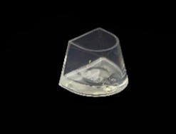 |  |  | HPR 26 |  |  | 160
27 |  | 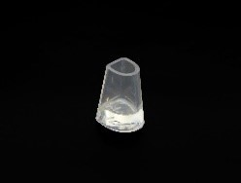 |  |  | HPR 27 |  |  | 120 |  |  | 170
28 |  | 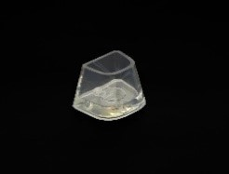 |  |  | HPR 28 |  |  | 120 |  |  | 170
29 |  | 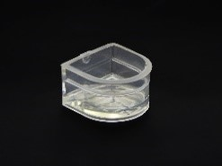 |  |  | HPR 29 |  |  | 160
30 |  | 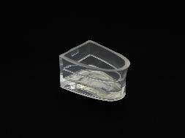 |  |  | HPR 30 |  |  | 120 |  |  | 170
31 |  | 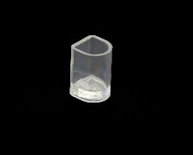 |  |  | HPR 31 |  |  | 120 |  |  | 170
32 |  | 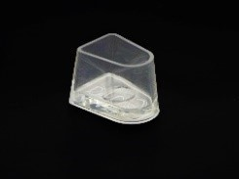 |  |  | HPR 32 |  |  | 120 |  |  | 170
33 |  | 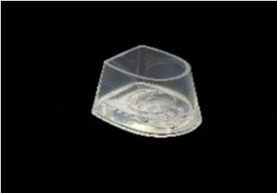 |  |  | HPR 33 |  |  | 120 |  |  | 170
34 | 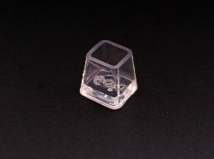 |  |  |  | HPR 34 |  |  | 120 |  |  | 170
35 | 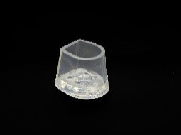 |  |  |  | HPR 35 |  |  | 120 |  |  | 170
36 | 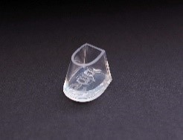 |  |  |  | HPR 36 |  |  | 120 |  |  | 170
37 | 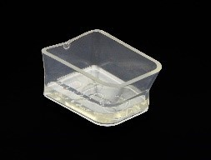 |  |  |  | HPR 37 |  |  | 200
38 | 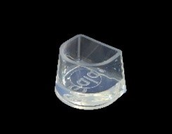 |  |  |  | HPR 38 |  |  | 120 |  |  | 170
38 | 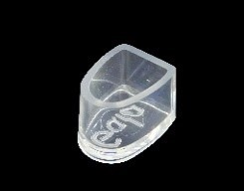
39 | 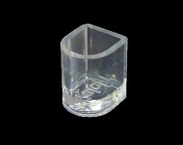 |  |  |  | HPR 39 |  |  | 120 |  |  | 170
40 | 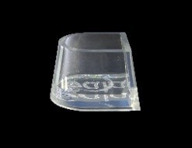 |  |  |  | HPR 40 |  |  | 120 |  |  | 170
41 | 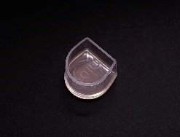 |  |  |  | HPR 41 |  |  | 120 |  |  | 170
42 | 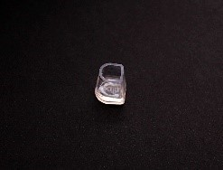 |  |  |  | HPR 42 |  |  | 170
43 | 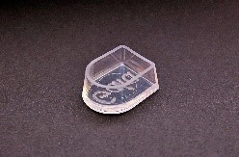 |  |  |  | HPR 43 |  |  | 120 |  |  | 170
44 | 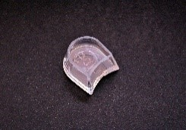 |  |  |  | HPR 44 |  |  | 200
45 | 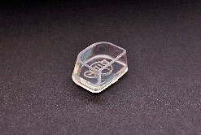 |  |  |  | HPR 45 |  |  | 180
46 |  |  |  | 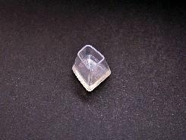 | HPR 46 |  |  | 160
47 |  |  |  | 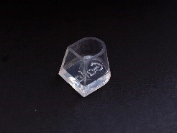 | HPR 47 |  |  | 120 |  |  | 170
48 |  |  |  | 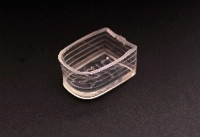 | HPR 48 |  |  | 120 |  |  | 170
49 |  |  |  | 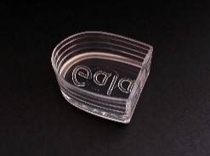 | HPR 49 |  |  | 220
50 |  |  |  | 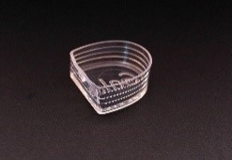 | HPR 50 |  |  | 220
51 |  |  |  | 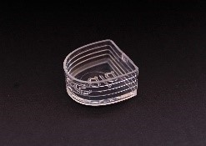 | HPR 51 |  |  | 180
52 |  |  |  | 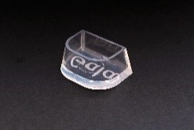 | HPR 52 |  |  | 140
53 |  |  |  | 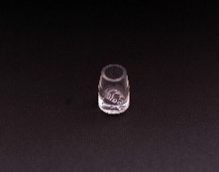 | HPR 53 |  |  | 140
54 |  |  |  | 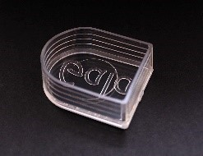 | HPR 54 |  |  | 120 |  |  | 170
55 |  |  |  | 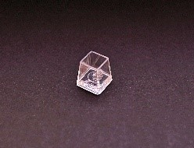 | HPR 55 |  |  | 250
57 |  |  |  | 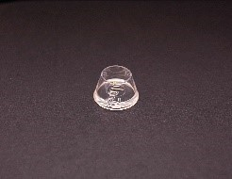 | HPR 57 |  |  | 120 |  |  | 170
58 |  |  |  | 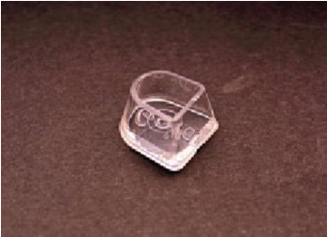 | HPR 58 |  |  | 120 |  |  | 170
59 |  |  |  |  | HPR 59 |  |  | 120 |  |  |  | 170

